BADMUS IBUKUN BOLANLE

use movie;

-- 1.

select mov_title,mov_year

from movie;

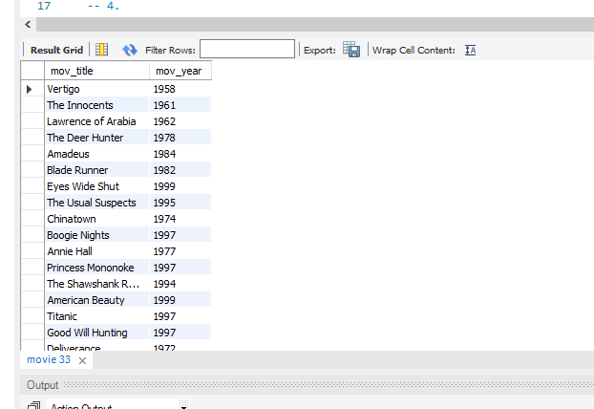

-- 2.

select mov_year,mov_title

from movie

where mov_year = 1999;

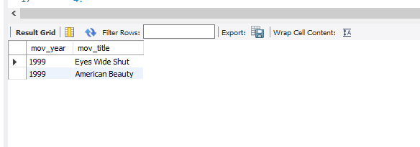

-- 3.

select mov_year,mov_title

from movie

where mov_year < 1998;

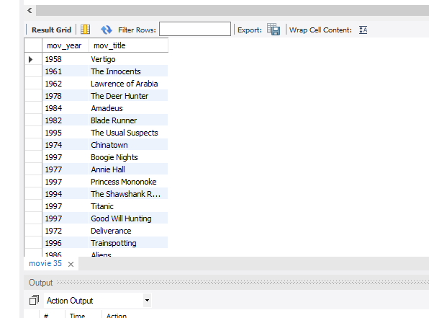

-- 4.

select rev_name,mov_title

from reviewer,movie;

-- 5

select rev_name,rev_stars

from reviewer,rating

where rev_stars >= 7;

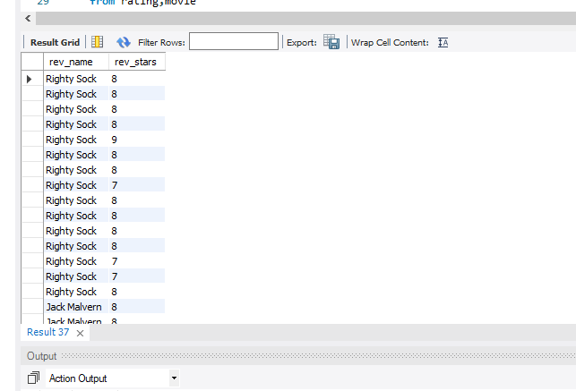

-- 6

select mov_title,rev_stars

from rating,movie

where rev_stars is null;

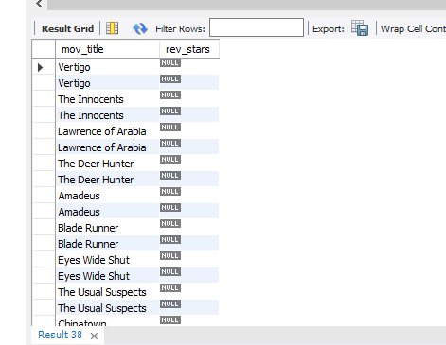

- 7.

select rev_name,rev_stars

from rating,reviewer

where rev_stars is null;

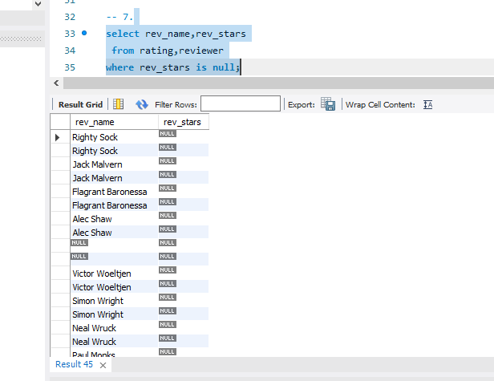

-- 8.

select mov_title,dir_fname,di_lname

from movie,director

where mov_title like 'eyes wide shut';

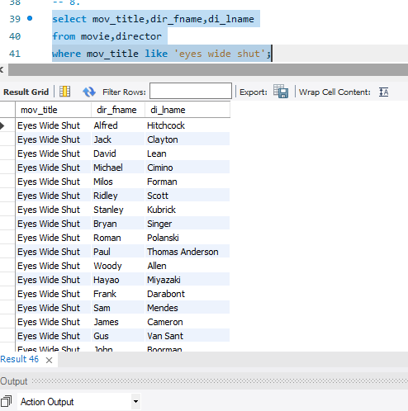

-- 9.

select rev_name,rev_stars FROM rating, reviewer

where rev_stars is null;